**OMIS 651 BUSINESS SYSTEMS ANALYSIS AND DESIGN**

**PROJECT REPORT**

**HOME-IN-ONE**

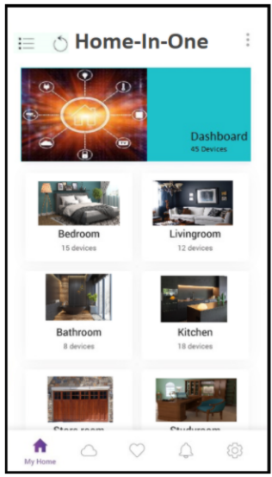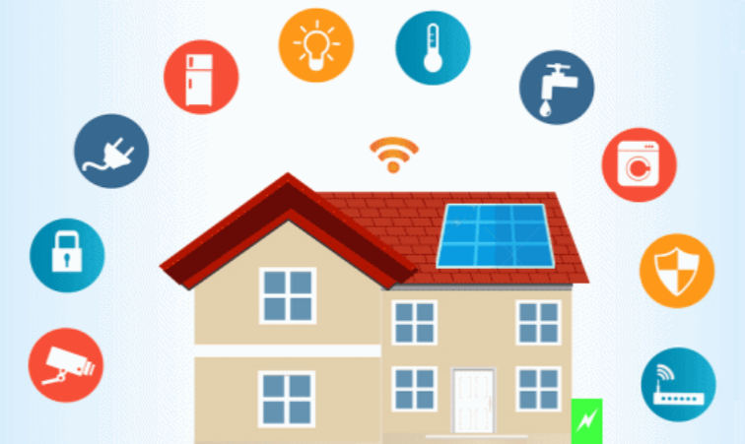

Prepared by:

|  |  |
| --- | --- |
| **Leela Sai Mounika**  **Bandaru** | **Z1889224** |
| **Sara Doty** | **Z1575618** |
| **Margaret Schrader**  **Frank Affatigato** | **Z1025295**  **Z1860143** |

**Table of Contents**

Challenges and Proposed Solutions 4

**Challenge 1** 4

**Challenge 2** 4

**Challenge 3** 5

**Challenge 4** 5

**Challenge 5** 5

Five Factor Analysis 6

User Interface 8

Use Case List 10

Use Case Diagram 11

Use Cases 12

Class Diagram 20

Sequence Diagram 21

State Machine Diagram 22

Testing Approach 23

Test Cases 23

Test Case ID 1 23

Test Case ID 2 24

Test Case ID 3 25

Test Case ID 4 26

Test Case ID 5 27

Test Case ID 6 28

Acquisition Strategy 29

Transition Plan 29

Requirements 29

Cost Analysis 30

Conclusion 31

Challenges and Proposed Solutions

Today’s consumers are looking for more ways to make their home smart. Unfortunately, there are many products and companies on the market and consumers are having to use multiple different apps to control various smart home products.  Consumers want the freedom to by any new innovative smart device from any company but control all their devices on one app.

The smart home market is dramatically growing and changing every day with new innovative devices and many new companies are starting business in this space.  Below are three of the more established players in the market:

***Meres***

Meres was founded in 2016 and is a leading supplier of Wi-Fi and smart home devices and services.  They serve more than 1 million customers from 20 different countries.  Meres product line covers many smart home products such as covers smart plugs, smart bulbs, switches, smart surge protectors, smart garage door openers and smart radiator thermostats.

***Kasa***

Kasa was founded in 2015 and builds products for the smart home market.  They provided customer centric products that cover security camera, Light Switches, lighting, and smart plugs.

***Ring***

Ring is well known in the smart device space.  They started with reinventing the doorbell.

**Challenge 1**

Because of the number of smart home products and companies in the market today, it is inevitable that one consumer can over time obtain smart devices through multiple companies.  Consumers do not want to get rid of a device just because they do not match with the product line they already have.

**Solution**

Allow consumers to purchase any smart device on the market regardless of company that develop the device.

**Challenge 2**

Today consumers may have to download multiple apps on their phone to control multiple smart devices they may have in their home.  This can be aggravating for the consumer because they must learn multiple apps and must clutter their phone with multiple apps.

**Solution**

Allow consumers the freedom to buy any device they want in the smart home space but control all these devices through one app.

**Challenge 3**

New smart home device companies are joining into the market all the time and are producing new innovative products.  Consumers do not want to be locked into one brand of product when innovative ideas are coming from multiple companies.

**Solution**

Allow consumers the freedom to buy any device they want in the smart home space but control all these devices through one app.

**Challenge 4**

Cybersecurity is a huge problem when you have many personal applications in one device. The risk of hackers is high, and that could lead to very dangerous situations.

**Solution**

Invest in a higher amount of security solutions so that our application is more secure than any other smart device application out there.

**Challenge 5**

With the number of products we are adding to one application, there is a chance for overload when too many people are using the app at the same time for too many different things.

**Solution**

Consider having more bandwidth during certain times of the day (busy times like right after getting home from work). This will make sure the application does not crash frequently when consumers really want to use it.

**Technical Considerations**

 The new app will be built with the understanding that all smart devices will be using the same backend technology and the new app will be able to control all smart home devices regardless of manufacturer of the device.

Five Factor Analysis

|  |  |
| --- | --- |
| **Factor** | **Approach** |
| Size | Development - A small team will be required to develop the application. Integration – Medium. The application is a platform for simple device management. |
| Criticality | Simple design that is not integrated for highly critical aspects of smart devices. |
| Dynamism | Application is designed to be highly dynamic and adaptable. |
| Personnel | Development – High. Integration and Maintenance – High; application will require continuous presence of experts to maintain the application. |
| Culture | Development and Integration – Thriving on chaos. |

The development of Home-In-One takes on an agile approach to software development. There are constantly new smart devices being created by different companies all the time in this environment. The Home-In-One will need to be adaptable to the wide variety of smart devices and the software that they use. Using a plan driven approach would make it very difficult to integrate new devices and systems within the software.

**Size:** With there being such a large variety of players in the smart device market, Home-In-One will require a small team of experts for the initial development to ensure that the application is compatible with all of them. The team will be required throughout the life of the application since there will always be new devices being created in the smart device market.

**Criticality:** The application is designed to manage simple characteristics of a smart device such as turning a specific light on and off. Testing on safety critical products will not be a responsibility in the development of the application.

**Dynamism:** Home-In-One is designed to manage many different smart devices in a home including lights, fans, televisions, washing machines, kitchen appliances, etc. With such a wide variety of products that need to be managed in the software, it would be best to exercise the eXtreme programming method. With so many aspects to the Home-In-One software development process, it would be best break down each phase of the development and plan each step accordingly. This will also be an appropriate method to manage the continuous integration of the application that will be needed as new smart devices enter the market.

**Personnel:** The development and maintenance of the application will require a small team of experts throughout its lifecycle. The project will require experts that are familiar with software integration and compatibility.

**Culture:** The culture of the development process will be will be a more chaotic since it will constantly need to be updated to be compatible with different types of applications.

User Interface

Below is the Home-In-One App login page.

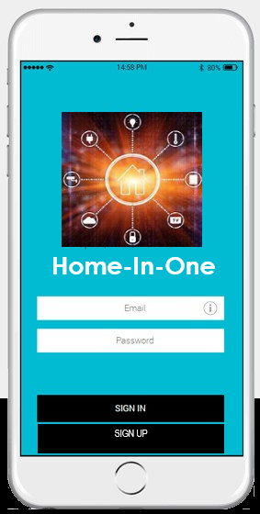

The dashboard (pictured on the left) allows users to choose the room/area in which they would like to see their enabled devices. Once they enter the room/area (pictured on the right), they can see said enabled devices, and make decisions based on their needs. Ex: Toggle lights on/off, close or open the garage door, make sure entrances are locked, etc.

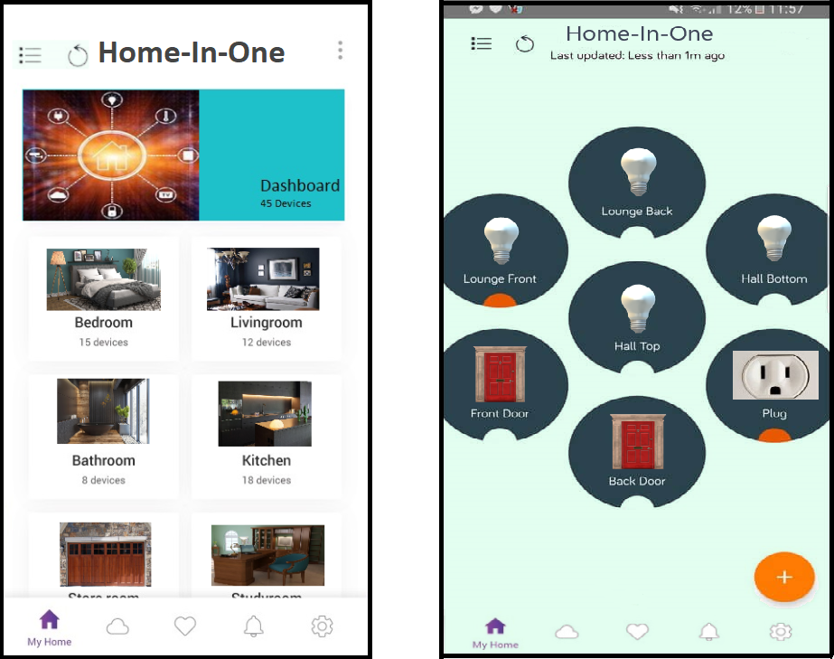

The picture below is the add device home screen that allows you to connect eligible smart home devices based on the type of system. Once you pick a system it will have you scan your barcode, pair the device, and save it to your device screen for easy access.

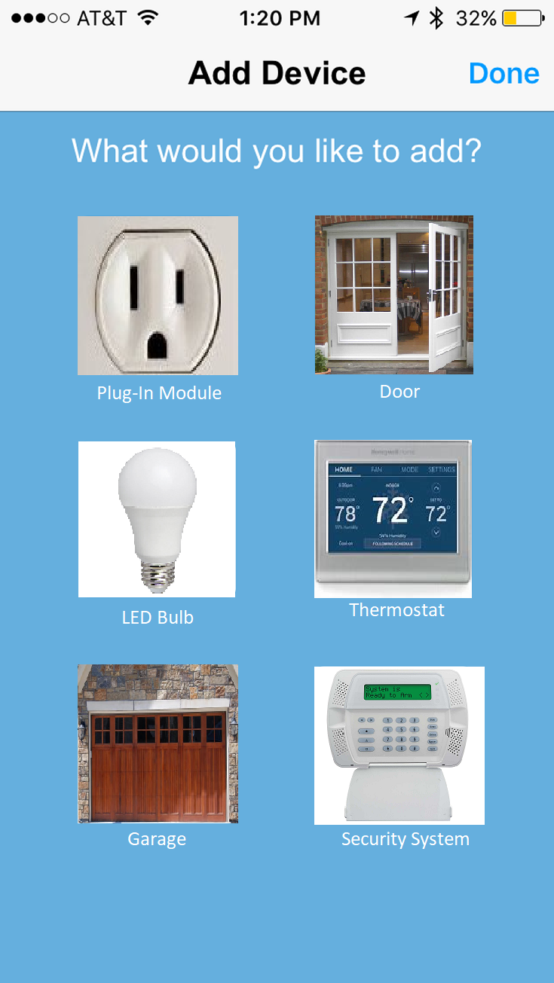

Below we can see a user’s phone home screen. Home-In-One will send users notifications based on what type of notification the user has opted into receiving. Here, the user has a notification set up to let them know that the garage door has closed, and it will pop-up in the phone notification center.

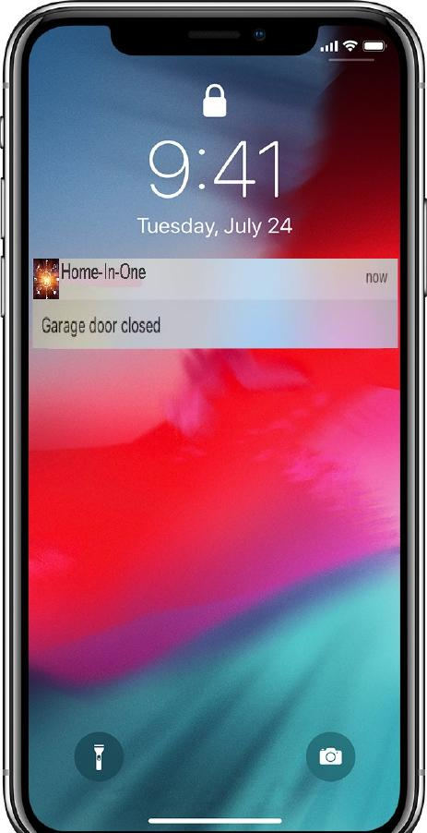

Use Case List

The user cases for the new application have been broken into three categories.

**Account**

|  |  |
| --- | --- |
| **Use Case Number** | **Use Cases** |
| UC-Account-1 | Setup Account |
| UC-Account-2 | Manage User |
| UC-Account-3 | Add User |
| UC-Account-4 | Remove User |
| UC-Account-5 | Manage WIFI |
| UC-Account-6 | Manage User Details |
| UC-Account-7 | Manage Credit Card |
| UC-Account-8 | Add Credit Card |
| UC-Account-9 | Delete Credit Card |
| UC-Account-10 | Manage Password |
| UC-Account-11 | Login |
| UC-Account-12 | Registration |
| UC-Account-13 | Logoff |

**Administration**

|  |  |
| --- | --- |
| Use Case Number | Use Cases |
| UC-Admin-1 | Setup Third-Party Device Vendor |
| UC-Admin-1 | Pay third-party device vendor for usage |
| UC-Admin-2 | Periodic billing to Account Holder |

**Device Management**

|  |  |
| --- | --- |
| Use Case Number | Use Cases |
| UC-Device-1 | Setup Device |
| UC-Device-2 | Remove Device |
| UC-Device-3 | View Device History |
| UC-Device-4 | Turn on Device. |
| UC-Device-5 | Turn off Device. |

Use Case Diagram

The use case diagram below shows each use case that the account holder will use to manage their account and devices. In addition, it shows how the admin user will use for backend functions.

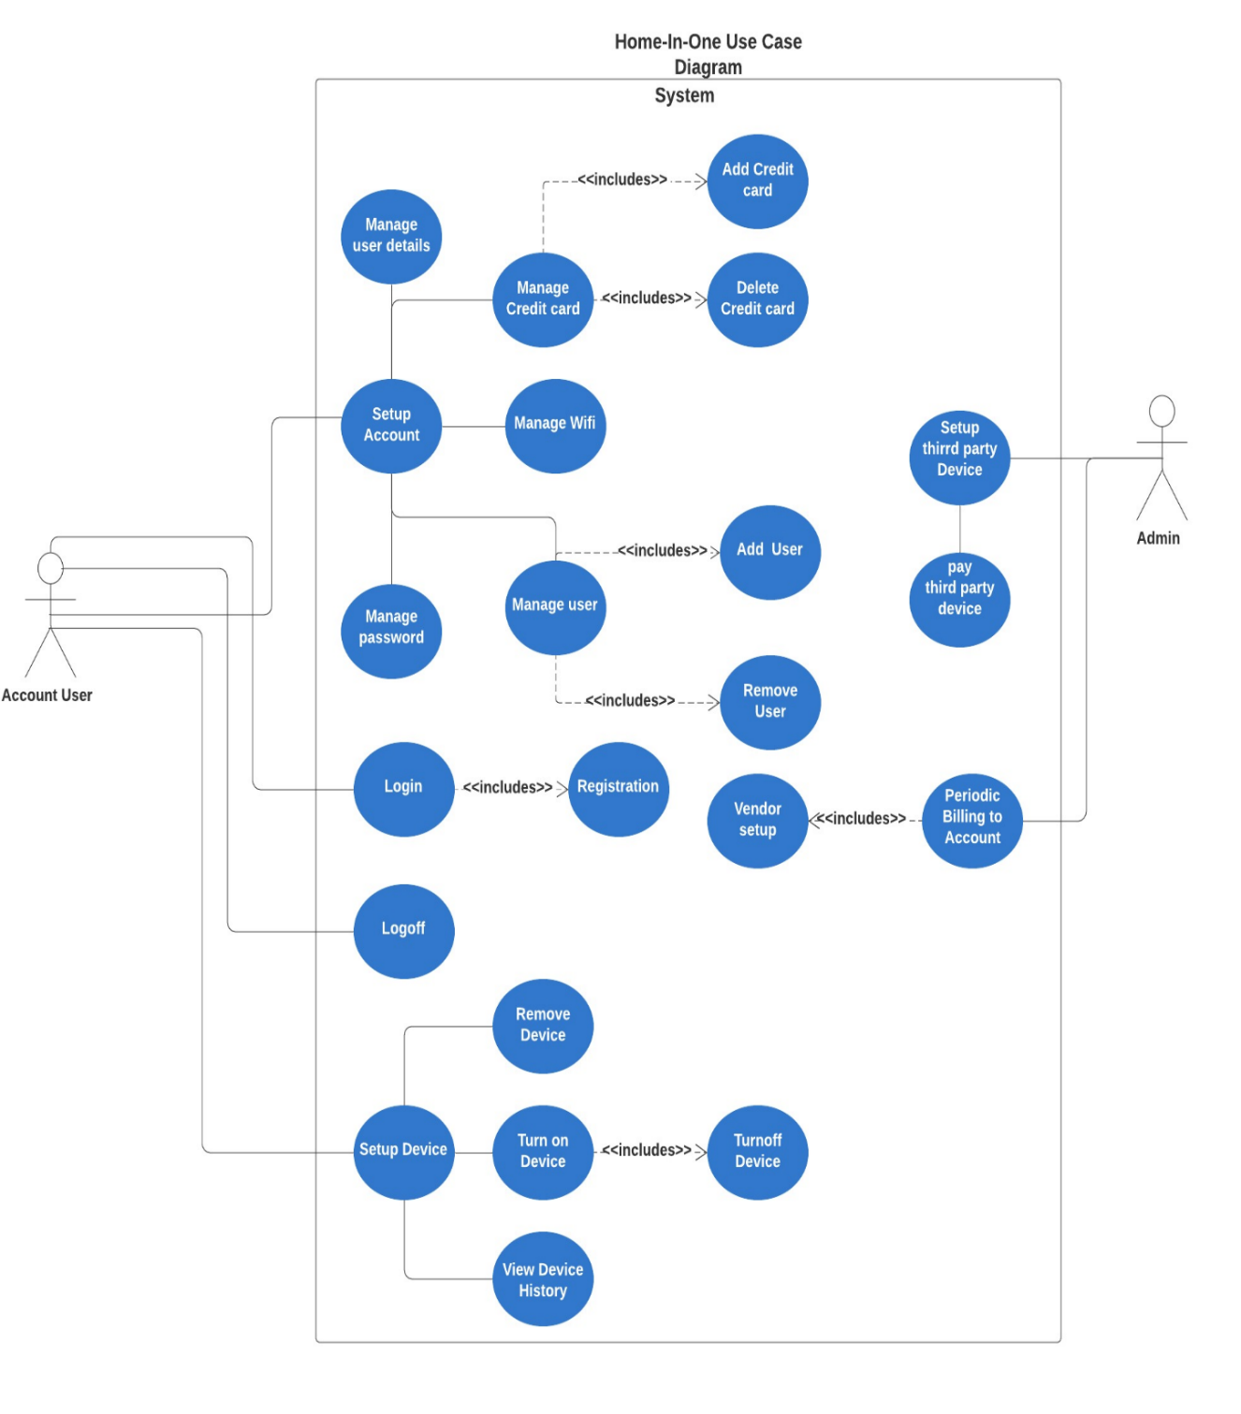

Use Cases

|  |  |  |  |
| --- | --- | --- | --- |
| **Use Case Name:** Setup Device | | **ID:** UC-Device-1 **Priority:** | |
| **Actor:** Account User | | | |
| **Description:** The device needs to be activated on the application and linked to the third-party vendor. | | | |
| **Trigger:** The User wants to Setup a new device that is managed in the application  **Type:**  External | | | |
| **Preconditions:**  Account has been setup and active.  Devices available for setup are on screen. | | | |
| **Normal Course:**  1.0 Setup Device  1. User selects a device to setup  2.User Scans device bar code (Alternative course 1.1)  3.System confirms bar code  4.System checks if device is on  5.System Links device to third-party vendor  6.User selects to complete device setup  7. System generates and saves account device ID | | **Information for Steps:**  Allowed devices.  Device bar code  Vendor Link | |
| **Alternative Course:**  1.1 No Bar Code on Item.  1. User selects option “No Bar Code on box” and system will cancel out of setup. | |  | |
| **Postconditions:**  Device activated on user account.  Device is added to user billing account.  Vendor is notified their device is linked to New Application. | | | |
| **Exceptions:**  E1 System gives message “Not able to validate bar code.” (Occurs At step 2)  E2 System gives message “Device cannot be located turn on device.” (Occurs at step 3)  E3. System gives message “Cannot link device; try again later” if vendor cannot be reached. (Occurs at step 5)  E4. System gives message “No vendor instructions available.” (Occurs at step 6)  E5. System gives message “Cannot add device; try again later.” (Occurs at step 7)  E6. System gives message “Cannot save device to account; try again later. (Occurs at step 9) | | | |
| **Summary Inputs** | **Source** | **Outputs** | **Destination** |
| User Account  Allowed devices.  Device Instructions  Device ID  Account ID  Device Bar Code | Account Datastore  Device Datastore  User Account  Device Box | Device Ping Response  Account Device ID  Account Device List  Vendor Link | Application  Account Device Datastore  Account Device Datastore  Vendor Datastore |

|  |  |  |  |
| --- | --- | --- | --- |
| **Use Case Name: Remove Device** | | **ID:** UC-Device-2 **Priority:** | |
| **Actor:** Account User | | | |
| **Description:** Remove a device from the account | | | |
| **Trigger: T**he User wants to remove a device that is managed in the application  **Type:** External | | | |
| Preconditions: Active device is on account. | | | |
| **Normal Course:**  1.0 Activate Device.  1.User requests to view their devices.  2. User picks device  3. User requests to remove a device from  account (Alternative course step 2.0)  4. System asks user if they are sure  5. User responds with Yes  6. System deletes device from user account  7. System informs billing module to stop bill effective today's date | | **Information for Steps:**  Account Device List  Device Removed | |
| **Alternative Course:**  2.0 User closes page as no device no listed  System goes back to home page. | |  | |
| **Postconditions:**  Device is no longer attached to the account.  Device is no longer available. | | | |
| **Exceptions:** | | | |
| **Summary Inputs** | **Source** | **Outputs** | **Destination** |
| Active Device List | Device Datastore | Device Removed from device list  Device removed from billing account. | Device Datastore  Billing Datastore |

|  |  |  |  |
| --- | --- | --- | --- |
| **Use Case Name: Setup Account** | | **ID:** UC-Account-1 **Priority:** High | |
| **Actor:** Account User | | | |
| **Description:** Users wants to set up an account profile | | | |
| **Trigger:** Smart device has been bought that are usable on the application  **Type:** Internal | | | |
| **Preconditions:**  Smart Home devices have been bought.  Application has been installed through IOS or Android. | | | |
| **Normal Course:**  1.0. Setup account.  1.User has installed the Home-In-One application  2. User is immediately prompted to log-in or create  account  3. User clicks setup account if first time using app  4. User inputs personal information for account  setup  5. App asks for e-mail address as username  6. App asks user to create a password and confirm  password  7. Username and password are created successfully,  and user goes back to log-in page. | | **Information for Steps:**  App downloaded,  Main log-in screen cannot bypass.  E-mail links all devices  Requirements: at least 8 characters, a number, and at least one special character | |
| **Alternative Course:** | |  | |
| **Postconditions:**  Account Profile has been setup. | | | |
| **Exceptions:**  E1. Password does not have all requirements must create using a different password and bypassing a captcha to ensure they are not a bot. (occurs at step 6.) | | | |
| **Summary Inputs** | **Source** | **Outputs** | **Destination** |
| App downloaded.  User ID | Account User  Account User | User log-in  Password created.  Account created. | Account Profile Setup |

|  |  |  |  |
| --- | --- | --- | --- |
| **Use Case Name: Add Credit Card** | | **ID:** UC-Account-8 **Priority:** High | |
| **Actor:** Account User | | | |
| **Description:** User wants to add credit card details to their account in the application. | | | |
| **Trigger:** User needs a credit card for payment purpose.  **Type:** External | | | |
| **Preconditions:**  Account has been setup.  Account active  Credit card is available. | | | |
| **Normal Course:**  1.0 Add Credit Card  1. User clicks on Billing tab  2.User requests to add credit card number  3. User inputs credit card number (Alternative  Course 2.0)  4. User inputs credit card expiration month and year  5. User inputs CCV  4. Click save and then exit from Billing tab.  5. User can add and save multiple credit cards on one account. | | **Information for Steps:**  Payment Instructions  card holder name, card number expiration date and security pin (CVV)  Add and save more credit cards details for future purpose. | |
| **Alternative Course:**  2.0 Two Factor Authentication  1.If user enables two factor authentications while  entering credit card details.  2. System displays “Enter security code”. (Occurs at  step 3) | |  | |
| **Postconditions:**  1.Credit card is added to the Billing account. | | | |
| **Exceptions:**  E1. User enters invalid credit card number format.  System displays “Incorrect credit card details”. Please try again. (Occurs at step 3)  E2 User enters invalid month or year.  System displays “Incorrect credit card details”. Please try again.  E3 User does not input CVV. (Occurs at step 5)  System displays “Incorrect credit card details “. Please try again. | | | |
| **Summary Inputs** | **Source** | **Outputs** | **Destination** |
| Username or ID  Credit Card details | Account User  User Account | User sign-in  Added credit cards. | Account User  Datastore |

|  |  |  |  |
| --- | --- | --- | --- |
| **Use Case Name:** Manage WIFI | | **ID:** UC-Account-5 **Priority:** High | |
| **Actor:** Account User | | | |
| **Description:** Connect devices to WIFI. | | | |
| **Trigger:** All smart devices need to be connected to the Internet to be managed in the application.  **Type:** External | | | |
| **Preconditions:**  Application has been downloaded.  User account has been created.  User is logged into to account.  Smart devices have been installed into home.  Smart devices are connected to a power source.  User has access to the Internet.  User has router that can connect devices to WIFI. | | | |
| **Normal Course:**   1. User requests to connect to WFI on application.   (Alternative course 2.0)   1. User inputs WIFI ID 2. User inputs WIFI Password 3. System confirms it can link to WIFI input. | | **Information for Steps:**  Router to connect to WIFI. | |
| **Alternative Course:**  2.0 Hardwire device.  1. Device is hardwired to the modem. There is no  access to WIFI. (Occurs at step 1) | | **Information for Steps:**  Message prompts when the application is not responding properly. | |
| **Postconditions:**  Devices connected are connected to the network.  Devices are managed through the application.  Software updates. | | | |
| **Exceptions:**  E1. Message displaying “Not connected to network” when Internet connection has been lost. (Occurs at  Step 4)  E2. Message displaying “incorrect WIFI password” when user has entered in an incorrect password. (Occurs at  Step 3) | | | |
| **Summary Inputs** | **Source** | **Outputs** | **Destination** |
| Network search  WIFI Password | User account  Router  Device | Device connection with WIFI | Device appearing in application. |

|  |  |  |  |
| --- | --- | --- | --- |
| **Use Case Name:** Account Login | | **ID:** UC-Account-11 **Priority:** High | |
| **Actor:** Account User | | | |
| **Description:** User wants to login into the account. | | | |
| **Trigger:** The User want to login into account of the application created**.**  **Type:** External | | | |
| **Preconditions:**  Account signup  Account active | | | |
| **Normal Course:**  1**.** User requests to login to the account.  2. System asks to enter login credentials  3. User enters login credentials  4. click on login button  5.System displays home page of the application  6. User requests to change the password | | **Information for Steps:**  Username and password  Correct Username and password are entered.  Forgot password. | |
| **Alternative Course:**  2.0 User ends the use case.  The system ends the use case when user click on the exit button at the login page. | |  | |
| Postconditions:  User able to login and those details stored in the application. | | | |
| **Exceptions:**  E1. User enters wrong user id or password while adding details. (Occurs at step 3)  System displays “Invalid username or password “. Please try again.  E2 User enters same password as before or not strong password (Occurs at step 3)  System displays “password is already used "or System displays “Enter strong password “ | | | |
| **Summary Inputs** | **Source** | **Outputs** | **Destination** |
| Account name  User ID  Password | User account  User account  User account | User sign-up  User login  User change password | User Account  User Account  User Account |

Device Management Diagram

Below is a general diagram depicting how devices can be managed within the application. Users will be able to access a similar diagram in their application that will be used as an illustration to find the devices that they want to manage. Having an illustration of their home in one application will make it much easier for a user to manage all their smart devices compared to having multiple applications.

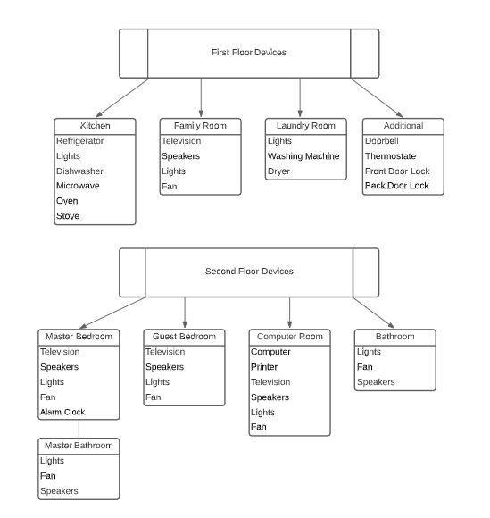

Class Diagram

This UML Class diagram represents the entire system for the new Application. The Account class has the most relationships with other classes in the system. Most of the relationships below are composite relationships. For example, the users, credit card, address and account device are part of the account class. The account device class has a dependency relationship to the possible allowed devices.

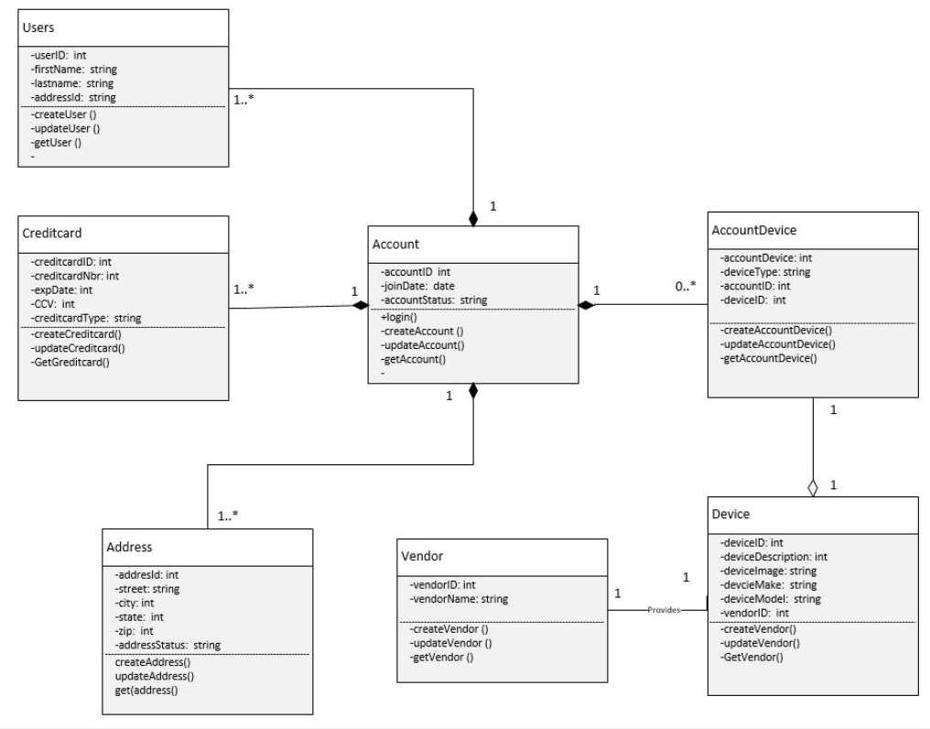

Sequence Diagrams

The sequence diagram represents interaction between objects in a single use case. The first step is to define the user who initiates the interaction. And then the message sequence between the sub system. There are synchronous messages and return message sequences which represents there is communication between objects in the below diagram.

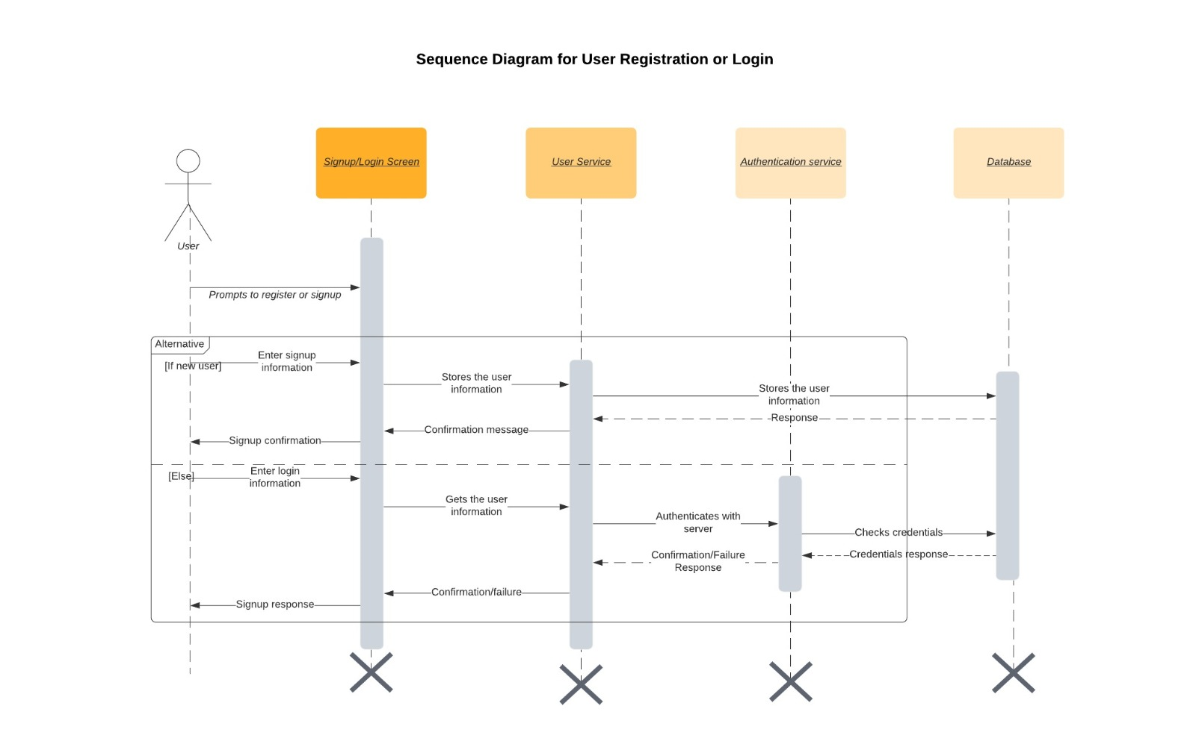

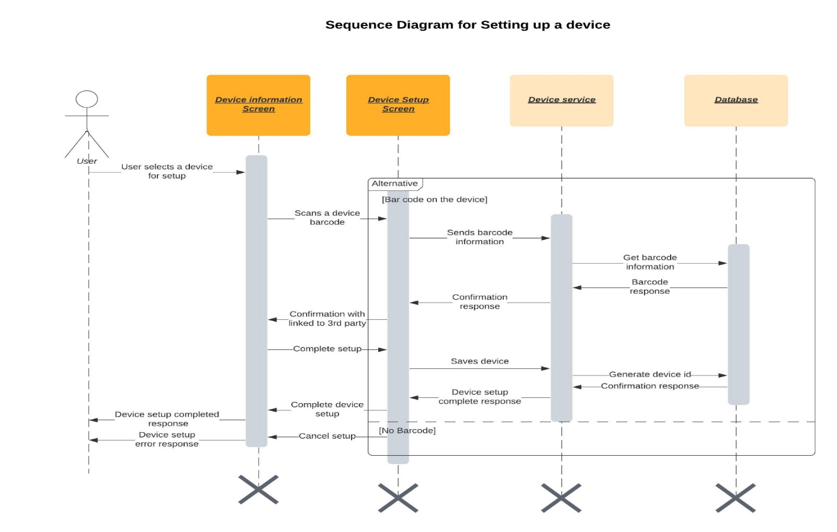

The sequence diagram represents interaction between user and the device screens (Device information screen, Device setup screen). There can be a couple of alternate courses when setting up the device, for example device service cannot get a response from device whether it can be turned on or not, but for simplicity reasons we only depicted only one alternate course here i.e., whether a barcode is found on the device or not. This depicts both successful completed device setup flows and errored response to use when the device barcode is not found.

State Machine Diagram

The state machine diagram shows the transition between states in a project where conditions need to be met before the next state can be performed. Once the specific conditions are met, a door opens, and you can move on to the next state which continues throughout until all occurrences can be performed creating a loop to bring you back to the beginning.

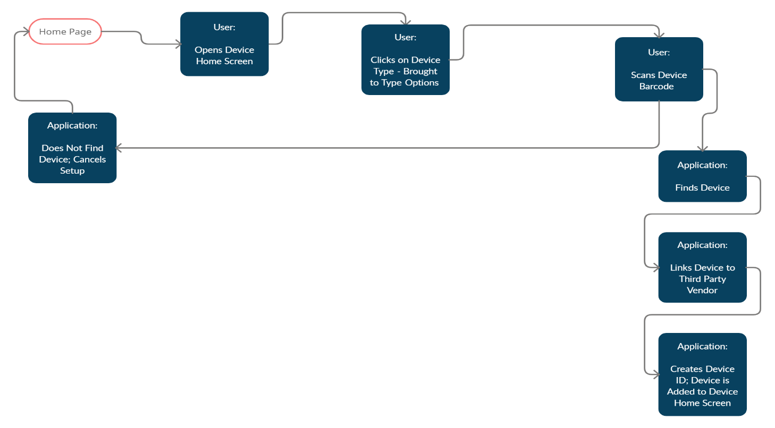

Testing Approach

Testing will be done during the two-week sprints by the software engineers. The testing approach will be test-driven development so the test cases will be coded prior to the development of the actual code and then run once the code is ready to be tested. These same test cases will then be added to the automated test bed so that each time code is released, the same tests can be executed to look for issues.

**Testing Environment**

The application will have a development, QA and pre-production environment to validate the application code.

**Testing Tools**

VersionOne will be used as a tool to manage stories and software defects.

Test Cases

|  |  |
| --- | --- |
| Test Case ID 1 | TC – Account Login - 1 |
| **Component** | Application Login Screen |
| **Purpose of Test Case** | To ensure that users can login with given credentials, such as email and password. Can also be used to test Two Factor Authentication for extra security measures (2FA). |
| **Functional Test Type** | Usability and Security Testing |
| **Pre-Conditions** | * Account active * Email verification. * Application downloaded. * Password creation. |
| **Inputs** | * Account ID * Password * Email address. |
| **Expected Outputs** | * Login Successful |
| **Alternative Output** | * Error message is displayed “Invalid username or password.” |
| **Post-Conditions** | Successful login  Access to user interface and account |

|  |  |
| --- | --- |
| Test Case ID 2 | TC – Network Identification - 1 |
| **Component** | User interface and list of networks. |
| **Purpose of Test Case** | To test that the application is properly finding surrounding WIFI networks. |
| **Functional Test Type** | Integration testing. |
| **Pre-Conditions** | * Application downloaded. * Logged into account. * Active Internet connection. * Smart devices already connected to WIFI. |
| **Inputs** | * Network ID * Wi-Fi Password. |
| **Expected Outputs** | Access to smart devices that are connected to the WIFI Network. |
| **Post-Conditions** | WIFI Connection  Manageable devices appear on user interface. |

|  |  |
| --- | --- |
| Test Case ID 3 | TC – Device Removal - 1 |
| **Component** | Active device list |
| **Purpose of Test Case** | To ensure a user can quickly and easily remove a device no longer needed. |
| **Functional Test Type** | Device Removal Testing |
| **Pre-Conditions** | * Logged into account. * Devices connected to account. * Active device list loaded. |
| **Inputs** | * Active device on Account |
| **Expected Outputs** | Device will disappear from active device screen. |
| **Post-Conditions** | Device no longer attached to account. |

|  |  |
| --- | --- |
| Test Case ID 4 | TC – User Notifications - 1 |
| **Component** | User Interface |
| **Purpose of Test Case** | Ensure user receives notifications they opt in to, and not receive notifications they disabled. |
| **Functional Test Type** | Usability Testing |
| **Pre-Conditions** | * Logged into account. * Go to settings. * Toggle notifications on/off. |
| **Inputs** | * Username * Password * Toggle notifications on/off. |
| **Expected Outputs** | User will receive notifications that are toggled “on” when the notification condition has been met. |
| **Post-Conditions** | Notifications pop-up on user’s phone when necessary. |

|  |  |
| --- | --- |
| Test Case ID 5 | TC – Setup Device |
| **Component** | Active device list |
| **Purpose of Test Case** | To ensure user can setup a new device that is managed in the application. |
| **Functional Test Type** | Add/Drop Testing |
| **Pre-Conditions** | * Account has been setup. * Account active * Devices available for setup are on screen. |
| **Inputs** | * User Account * Allowed devices. * Device Instructions * Device ID * Account ID * Device Bar Code |
| **Expected Outputs** | User will be able to setup device in the application after the account is activated. |
| **Post-Conditions** | Device activated on user account.  Device is added to user billing account.  Vendor is notified their device is linked to New Application. |

|  |  |
| --- | --- |
| Test Case ID 6 | TC – Turn-on Device |
| **Component** | Active device list |
| **Purpose of Test Case** | Ensure the user can turn on the device after the device setup. |
| **Functional Test Type** | Add/Drop Testing |
| **Pre-Conditions** | * Account active * User login * Device setup |
| **Inputs** | * User Account * Allowed devices. * Device Instructions * Device ID |
| **Expected Outputs** | User will be able to turn on the device for the application needed. |
| **Post-Conditions** | * No errors while using the turn on button. |

Acquisition Strategy

The Home-in-One will be made available for free on the Apple App Store and Google App Store starting July 1, 2021. The downloaded application will remain free. The application will receive revenue stream when the user links devices to the application and pays a monthly charge on their credit/debit card for the service. In the future there will also be a revenue stream when vendor devices are marketed on the site, and Home-in-one receives a percentage of the sale when selling vendor devices.

Transition Plan

This mobile application is new and is not currently available on the market. The application will be delivered with a minimal viable product and launched so that the team can learn and fail fast and iterate on what we find are additional customer needs.

Requirements

**Requirement Elicitation Technique**

Since home-in-one is modeled after existing smart home applications, we will use questionnaires as they are a more simplistic and cost-effective elicitation technique. We already understand the basic user requirements from existing applications such as Samsung SmartThings, Google Home, MyQ, etc. Questionnaires can be used to gain any additional information that we might need to improve upon these applications.

**Device Requirements:**

The application will require 520 MB of storage space on whatever device it is being installed on. The application will run optimally on and Internet speed of at least 5 MBPS. These requirements were determined based on the current Google and Apple Home storage needed for the application. Between some of the smart home applications listed, the average storage needed was 416 MB. Since Home-in-One will have more extensive device compatibility, we needed an additional 100 MB of storage for the application. An Internet Speed of 5 MBPS is the standard minimum speed needed for managing 10 smart home devices. 5 MBPS are required for every 10 devices that are connected to the WiFi.

# Cost Analysis

User: Any cost of our product to the user will be offset by the convenience our product will bring. Our app allows the user to only have one application on their device for all smart home products reducing time, cost, and resources that would have been otherwise spent.

Company: The upfront costs for Home-In-One will include a development team, software for app creation, licensing, management, legal team and integration with smart home device companies. Ongoing costs will include maintaining the app, security checkpoints and validation, and continuous upgrades and updates.

Conclusion

In conclusion, the new Home-in-One smart home app offers new features not currently available on the market by allowing one app to host multiple vendor devices in one application. This will reduce the complexity of having multiple applications to control internet of thing devices in your home. Consumers will have freedom to buy any device in the smart home space and control it through the Home-in-One app. In addition, the Home-in-One application has updated security features to reduce the chance of security attacks on your devices.

.